**Note on**

**Problem Framing, Problem Solving**

“Design thinking” is a hot topic in both the practitioner and academic press these days. For many, particularly in large organizations, it is a panacea, the means by which all problems can be solved. Indeed, “design thinking” offers a refreshing set of mindsets, skillsets and toolsets that are important to learn: observing and noticing, particularly around customers and users; framing and reframing a situation; imagining and designing a wide range of alternative futures; and rapid iteration, making and experimenting with those different futures.

“Design thinking”, however, is not the only set of approaches available to framing and solving problems. Critical thinking, scientific method, analytical thinking, systems thinking, inductive, deductive and abductive reasoning, and lean start-up methods all offer alternative approaches to framing and solving problems. In Problem Framing, Problem Solving, we introduce an Innovation Cycle grounded in the learning literature that accommodates many of these approaches to problem framing and solving. Our objective is to have you think about how you approach framing and solving problems, and become more cognizant of the methods and approaches that are appropriate in any given situation.

**Types of Problems**

Problems are often classified in terms of how much is known about them, or by the degree of complexity involved:

|  |  |  |
| --- | --- | --- |
|  | Problem Space Well-Defined | Problem Space Ill-Defined |
| Solution Space Well-Defined | **Simple Problems:** Dictate mostly exploitation and convergent activities within the current paradigm. | **Semi-wicked Problems:** Dictate consideration of new applications for existing technologies or capabilities |
| Solution Space Ill-Defined | **Complex Problems:** Dictate exploration of new ideas and realms, searching for better solutions while also exploiting what’s known | **Wicked Problems:** Dictate exploration of unknown territories |

(Adapted from Richardson, 2010)

Simple problems, or problems that are already defined, are easy to solve; defining the problem inherently defines a solution. Solving simple problems may lead to improvement—but not to innovation. Innovation requires that we grapple with “wicked” problems, such as climate change, global poverty alleviation, redesigning our transportation network (think Uber), or imagining the appropriate (and inappropriate) applications for artificial intelligence (Black Mirror, anyone?). “Wicked problems” are characterized by Volatility, Uncertainty, Complexity and Ambiguity (VUCA). They have many stakeholders with potentially radically different world views, their resources and constraints may vary over time, and there is no single right solution to them.

As far back as 1973, UC Berkeley faculty in the College of Environmental Design defined the term “wicked problem” and declared: “By now we are all beginning to realize that one of the most intractable problems is that of defining problems (of knowing what distinguishes an observed condition from a desired condition) and of locating problems (finding where in the complex causal networks the trouble really lies). In turn, and equally intractable, is the problem of identifying the actions that might effectively narrow the gap between what-is and what-ought-to-be” (Rittel & Webber, 1973).

Today, with the accelerating pace of change of technology confronting us with the need to innovate nearly everything around us to keep up (Brynjolfsson & McAfee, 2012) and higher and higher expectations from customers for the products and services they consume to be differentiated and customized to meet their individual needs and provide them with transformational experiences (Pine II & Gilmore, 1998) we face “wicked problems” in every organization we work in.

**Framing and Reframing**

At the heart of working with “wicked problems” is the ability to quickly frame and reframe the problem to be solved. The more linear and analytic processes to which we’ve become accustomed rarely open up the number of different frames that the more exploratory approaches of “design thinking” can (Beckman and Barry, 2015). Suppose, for example, that I asked you to build me a bridge. The problem solver in you might jump right in, asking how far it is across the river, what sits on either side, and which type of bridge (cantilever, suspension, etc.) would work best.

In the “design thinking” world, however, you would first step back and ask, Why do we need this bridge? Well, suppose I say that people need to get to the other side of the river. Now your mind bursts with a set of other alternatives: a boat, a tunnel, a wetsuit, a zipline. And, if you ask why again, you might find that I want to get a message to the other side. Suddenly that large investment you might have made in a bridge can be significantly reduced by instead facilitating my sending an email, floating a message in a bottle, yelling through a megaphone, and so on.

The process we introduce in PFPS aims to develop a mindset around framing and reframing. In doing so, it leverages not only the “design thinking” approaches, but also the “lean start-up” methods that urge the start-up team to “pivot” as early and often as needed to get to “product-market fit”.

**Innovation as a Learning Process**

The literature on how we learn provides a framework for problem framing and solving that accommodates multiple approaches to doing so. The model, depicted below, shows that as we learn, as individuals or as teams, we toggle between being present in the concrete world (concrete experience) and being in our heads (doing abstract conceptualization). And we toggle between doing analysis, asking why or doing what some call reflective observation, and doing synthesis, asking how and engaging in active experimentation (Beckman and Barry, 2007; Kolb and Kolb, 2005). The four quadrants formed by this learning framework highlight the four core skillsets of “design thinking” and more generally of problem framing and solving.

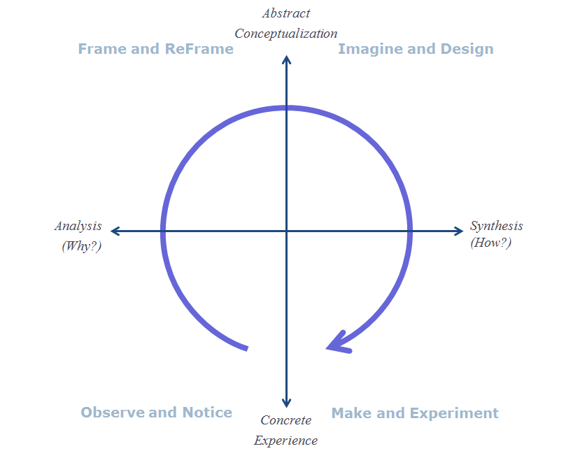

***Observe and Notice***

At the intersection of concrete experience and reflective observation or analysis work, we take in information about the world around us. For scientists, this means taking in information about the natural world, while for “design thinkers” or “lean start-up” practitioners this means learning about people, specifically customers and users, the environments in which they work and live, the problems they are challenged by in their lives, and the ways they solve those problems today. Being astute observers requires putting aside biases, actively listening, asking open-ended and probing questions, and eliciting and capturing stories. It also means looking at data with a critical eye, carefully forming hypotheses about causal relationships.

***Frame and ReFrame***

Still in analysis, but not in the abstract mode of learning, framing and reframing is the critical stage in which “design thinkers” look for patterns in the messy data collected in the “observe and notice” phase, and critically, step back and ask why. Scientists form hypotheses at this stage of their work. “Design thinkers” create “how might we?” questions that frame a problem, often from a particular point of view (e.g., that of the customer), and ultimately allow them to come up with a variety of options for answering that “how might we?” question. Hypotheses tend to set up something to be proven, while “how might we?” questions open up possibilities for exploration.

***Imagine and Design***

Imagining and designing happen in abstract thinking space, but are on the synthesis side of the learning model. Here divergent and convergent thinking come into play. Diverging requires generating a set of options, while converging requires selecting from among those options. It isn’t possible to do both at the same time. (You might pay attention to meetings you have at work, and how often the start with someone throwing out an idea, which people then argue about for some time until another idea is thrown out and argued, etc. This is a very unproductive approach, time consuming and not engaging for many of the participants. Much better to get all the ideas on the table first, and then to argue about how to move forward.) Diverging for “design thinkers” means imagining a wide range of alternative futures in response to the “how might we?” question derived from “framing and reframing”.

***Make and Experiment***

Often in the business world, this cycle gets stuck in the “imagine and design” phase as people strive to “finish” the idea through conversation and thought. “Design thinking” and “lean start-up” practitioners push for rapid experimentation, for bringing the ideas alive in some way, and then taking them back out into the concrete world and testing them, getting feedback on them from real potential customers, users and other stakeholders. Storytelling is one way to “make and experiment” or “rapid prototype”, as you “can’t tell a good story if you don’t have a good story to tell” (Riemer, 2017). Skills to be developed in this include being able to identify key elements of a solution to test, to creatively design ways of testing, and to actively listen to the feedback received.

In PFPS, we will introduce the mindset, skillset and toolset associated with each of these quadrants and let you practice them on your own and with your Applied Innovation teams.

.

**References**

Beckman, S. L., & Barry, M. (2007). Innovation as a Learning Process: Embedding Design Thinking. *California Management Review, 50*(1), 25-56.

Beckman, S. L., & Barry, M. (2015). Framing and Reframing: Core Skills for a Problem Filled World. *Rotman Magazine*. http://www.educationpost.com.hk/resources/mba/150428-mba-study-tips-framing-and-re-framing-core-skills-for-a-problem-filled-world#

Brown, Tim. (2008, September 7). *Definitions of Design Thinking*. Retrieved July 31, 2010, from Design Thinking: Thoughts by Tim Brown: http://designthinking.ideo.com/?p=49

Brown, Tim. (2008, June). Design Thinking. *Harvard Business Review*.

Brynjolfsson, E., & McAfee, A. (2012). *Race Against The Machine: How The Digital Revolution Is Accelerating Innovation, Driving Productivity, and Irreversibly Transforming Employment and The Economy .* Digital Frontier Press.

Kolb, A., & Kolb, D. (2005). *The Kolb Learning Style Inventory - Version 3.1, Technical Specifications.* HayGroup.

Kolb, D. A. (1984). *Experiential Learning: Experience as the Source of Learning and Development.* Englewood Cliffs, NJ: Prentice-Hall.

Mayfield, M. (2007). *Thinking for Yourself: Developing Critical Thinking Skills through Reading and Writing.* Boston: Thomson Higher Education.

Meadows, D. H. (2008). *Thinking in Systems: A Primer.* White River Junction, VT: Chelsea Green Publishing Company.

Owen, C. (2007). Design Thinking: Notes on its Nature and Use. *Design Research Quarterly, 2*(1), 16-27.

Pine II, B. J., & Gilmore, J. H. (1998, July-August). Welcome to the Experience Economy. *Harvard Business Review*, 97-105.

Pink, D. H. (2006). *A Whole New Mind: Why Right-Brainers Will Rule the Future.* New York: Riverhead Books Penguin Group.

Puccio, G. J., Murdock, M. C., & Mance, M. (2007). *Creative Leadership: Skills that Drive Change.* Thousand Oaks, CA: Sage Publications, Inc.

Puccio, G., Firestien, R., Coyle, C., & Masucci, C. (2006). A Review of the Effectiveness of Creative Problem Solving Training: A Focus on Workplace Issues. *Creativity and Innovation Management, 15*, 19-33.

Richardson, A. (2010). *Innovation X: Why a company's toughest problems are its greatest advantage.* San Francisco, CA: Jossey-Bass.

Rittel, H. W., & Webber, M. M. (1973). Dilemmas in a General Theory of Planning. *Policy Sciences, 4*, 155-169.

Senge, P. M., Roberts, C., Ross, R. B., Smith, B. J., & Kleiner, A. (1994). *The Fifth Discipline Fieldbook: Strategies and Tools for Building a Learning Organization.* New York: Doubleday Dell Publishing Group.

Sterman, J. D. (2000). *Business Dynamics: Systems Thinking and Modeling for a Complex World.* Burr Ridge, IL: McGraw-Hill Higher Education.